Paper Title
First and last name¹, First and last name²*, First and last name³, …
1.Scientific Degree, Department of …, Faculty of…., University of …, City, Country
2. Scientific Degree, Department of …, Faculty of…., University of …, City, Country
3. Scientific Degree, Department of …, Faculty of…., University of …, City, Country

*Corresponding author: E-mail@
Abstract
Text…………………………………………………………………………………………………………………………………………………………………………………………………………………………………………………………………………………………………………………………………………………………………………
Keywords: words
(لازم به ذکر است چکیده مبسوط علاوه بر اینکه در یک فایل جداگانه باید ارسال شود لازم است در فایل اصلی مقاله همانند ذیل گنجانده شود)
Extended abstract
Introduction
Text……………………………………………………………………………………………………………………………………………………………………………………………………………………………………………………………………
Materials and Methods
Subtitle
Text……………………………………………………………………………………………………………………………………………………………………………………………………………………………………………………………………
Results and Discussion
Text………………………………………………………………………………………………………………………………………………………………………………………………………………………………………………………………………
Conclusions
Text………………………………………………………………………………………………………………………………………………………………………………………………………………………………………………………………………
References
………………………………………………………………………………………………………………………………………………………………………………..
………………………………………………………………………………………………………………………………………………………………………………..

عنوان مقاله (به فارسی)
نام و نام خانوادگی نویسنده اول¹، نام و نام خانوادگی نویسنده دوم^{*2}، نام و نام خانوادگی نویسنده سوم³، ...
1. رتبه علمی، گروه آموزشی، نام دانشکده، نام دانشگاه، نام شهر، نام کشور
2. رتبه علمی، گروه آموزشی، نام دانشکده، نام دانشگاه، نام شهر، نام کشور
3. رتبه علمی، گروه آموزشی، نام دانشکده، نام دانشگاه، نام شهر، نام کشور

* نویسنده مسئول: ایمیل

چکیده
متن.............................................................................................................................................................................................................................................................................................................................................................................................................................................................................................................................................................................................................................................................................................
کلید واژه‌ها:...................................

مقدمه
متن.....................................................................................................................................................................................................................................................................................................................................................................................................................................................................................................................
مواد و روش‌ها
متن.....................................................................................................................................................................................................................................................................................................................................................................................................................................................................................................................
بحث
زیر عنوان
متن.....................................................................................................................................................................................................................................................................................................................................................................................................................................................................................................................
زیر عنوان
متن.....................................................................................................................................................................................................................................................................................................................................................................................................................................................................................................................

جدول 1- نتایج آنالیز هیدروژئوشیمیایی
Table 1. Results of hydrogeochemical analysis
 | K1 | K2 | K3 | K4 | K5 | K6 | K7 | K8 | K9
pH | 5.92 | 5.99 | 6.81 | 5.99 | 6.65 | 6.75 | 6.79 | 6.72 | 6.64
EC (µs/m) | 1792 | 1954 | 2520 | 2870 | 2880 | 2550 | 2520 | 2420 | 4510
Eh (mv) | 65 | 83 | 67 | 60 | 63 | 59 | 42 | 53 | 40
TDS (mg/l) | 890 | 946 | 1261 | 1436 | 1438 | 1288 | 1258 | 1209 | 2260
K (mg/l) | 17.85 | 20.2 | 19.75 | 25.6 | 22.88 | 18.8 | 19.4 | 19.6 | 21.3
Na (mg/l) | 296 | 302.5 | 309.7 | 373.2 | 397.9 | 251.4 | 308.7 | 317.28 | 825.6
Mg (mg/l) | 70.5 | 89.6 | 109.8 | 164.6 | 143.7 | 121 | 119.7 | 126.8 | 267.4
Ca (mg/l) | 247 | 228 | 472 | 514 | 416 | 514 | 427 | 416 | 580
So₄ (mg/l) | 682 | 466 | 1156 | 1763 | 1008 | 1416 | 989 | 1001 | 2717
Cl (mg/l) | 327 | 430 | 395 | 487 | 599 | 395 | 537 | 430 | 945
Hco₃ (mg/l) | 788.8 | 905.6 | 850.5 | 863.1 | 1124.6 | 832.2 | 1055.2 | 1084.2 | 1084.9

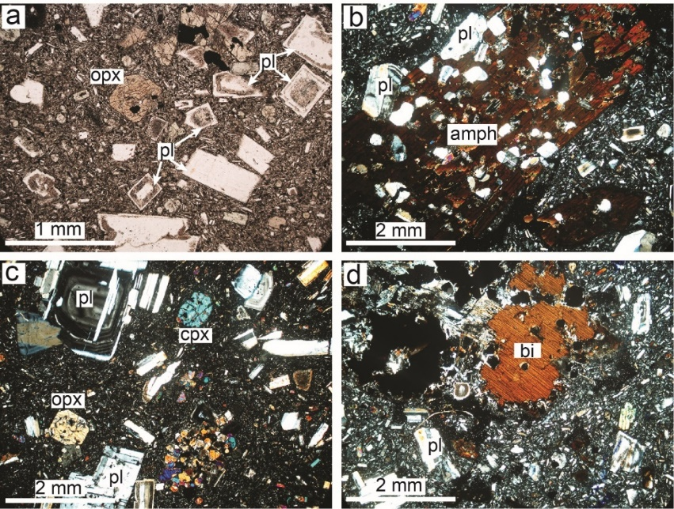
شکل 1- توضیحات. a) .............b) ...............c) ...................d) ......................
Fig. 1. Description. a) ……………. b) ……………….c) ………………. d) …………………….
نتیجه‌گیری
متن.....................................................................................................................................................................................................................................................................................................................................................................................................................................................................................................................
قدردانی
متن...................................................................................................................................................................................................................................................
References
Brophy, J.G., 2008. A study of rare earth element (REE)–SiO₂ variations in felsic liquids generated by basalt fractionation and amphibolite melting: a potential test for discriminating between the two different processes. Contrib. Mineral. Petrol. 156 (3), 337–357.
Berberian, M., King, G.C.P., 1981. Towards a paleogeography and tectonic evolution of Iran. Can. J. Earth Sci. 18 (2), 210–265.
Sajona, F.G., Maury, R.C., Bellon, H., Cotten, J., Defant, M.J., Pubellier, M., 1993. Initiation of subduction and the generation of slab melts in western and eastern Mindanao, Philippines. Geology 21 (11), 1007–1010.
Harrison, T.M., Leloup, P.H., Ryerson, F.J., Tapponnier, P., Lacassin, R., Chen, W., 1995. Diachronous initiation of transtension along the Ailao Shan-Red River shear zone, Yunnan and Vietnam, In: Ann Yin, Harrison, T.M. (Eds.), The Tectonic Evolution of Asia. Cambridge University Press, pp. 208-226.

