The study of thermal pattern changes on Mesijune salt dome, Zagros, Iran
Babak Samani¹, Sajjad Zareie²
- Department of Geology, Faculty of Earth Sciences, Shahid Chamran University of Ahvaz, Ahvaz, Iran (b.samani@scu.ac.ir)
- Department of GIS and remote sensing, Faculty of Earth Sciences, Shahid Chamran University of Ahvaz, Ahvaz, Iran (s_zareie@scu.ac.ir)
Abstract:
Split-window algorithm is an effective method for determination of land surface temperature. The main goal of this research is application of Split-window algorithm for determination of surface temperature pattern of Mesijune salt dome in the southeastern of Fars province in the Zagros Mountains. Land surface temperature (LST) analysis has made using of Landsat 8 TIRS and OLI sensors. The results of surface temperature pattern show the highest temperature (36°C) at the summit and the lowest temperature (30°C) at the marginal part of the salt dome. It seems that the higher temperature at the dome summit is related to the connection between the central parts of the dome with the basement salt column. While the lower temperature of the marginal parts of the dome can be due to the lack of connection between the salt dome and the salt source of Hormuz Series.
Keywords: Split-window algorithm, land surface temperature, Mesijune salt dome, Zagros.
Introduction
A salt dome is a mound or column of salt that has intruded upwards into overlying sediments (Fossen, 2016; Jackson and Hudec, 2017). Salt domes can form in a sedimentary basin where a thick layer of salt is overlain by younger sediments of significant thickness. Where conditions allow, salt domes can rise thousands of meter above the layer of salt from which they began growing. The development of salt domes can deform rock units into traps that hold oil and natural gas (Alipour et al., 2022; Burton and Dafov, 2023). They are often mined as sources of salt and sulfur. However, salt domes and other diapiric systems have a negative effect on surface water, underground water reserves, and soil quality (Shami et al., 2024). The impermeable nature of the salt can make them important sites for underground storage or underground disposal of hazardous waste. Unlike most other types of sediment, salt has the ability to change shape and flow when placed under enough pressure. To develop a salt dome, the pressure on the salt must be high enough to enable it to intrude the overlying sediments (Fossen, 2016). The pressure must be great enough to overcome several obstacles. These include the weight of overlying strata, the strength of overlying strata, frictional forces, and the force of gravity resisting uplift (Fossen, 2016; Jackson and Hudec, 2017). Two sources of pressure that have produced salt domes are the downward pressure of overlying sediment and the lateral pressure of tectonic movement (Fossen, 2016; Jackson and Hudec, 2017). If an area of weakness or instability develops in the overlying sediment, salt under adequate pressure can intrude into it. The weakness might be caused by extension fractures, a developing anticline, a thrust fault, or a valley eroded into Earth's surface above. Once the salt begins to flow, it can continue as long as the pressure on the salt is high enough to overcome the resisting forces. Flow will stop when the salt has risen to a height where equilibrium conditions exist. Salt domes can be very large structures. The salt cores range from 1 kilometer to 10 kilometers across. The parent rock units that serve as a source of salt are usually several hundred to a few thousand meters thick. The salt domes ascend from depths of between 200 and 2000 meter (or more) below the surface. They usually do not reach the surface. If they do, a salt glacier might form. Salt domes and adjacent sediments are considered as an example of a complex geological environment (Jackson and Hudes, 2017). Many researchers (e.g. Ranganathan, 1992; Younes, 2003; Hughes and Sanford, 2004; Geiger et al., 2006; Thorne et al., 2006) have conducted various studies on the mechanism of complex movements of salt in salt domes and salt glaciers, the thermal conduction of salt and the flow of surface saline water and groundwater aquifers around salt domes. Earth's surface temperature is one of the most important parameters in the global conditions, which is an important factor in controlling biological, chemical and physical processes of the earth (Zareie and Kabolizadeh, 2020). Earth's surface temperature is a function of the net energy at the earth's surface, which depends on the amount of energy reaching the earth's surface, surface emissions, humidity, and atmospheric airflow. Remote sensing methods and satellite images are some of tools that can be useful in estimating the surface temperature of the earth. One of the important applications of thermal remote sensing is to prepare land surface temperature (LST) map (Zareie et al., 2016; Rangzan et al., 2019; Zareie and Kabolizadeh, 2020). Landsat series and ASTER are the most important sensors that can be used to estimate the land surface temperature. The use of thermal remote sensing methods and satellite images processing is very efficient to identify and study geological phenomena (including salt domes). There are various studies in the field of morphology, structural geology and geochemistry of Iranian salt domes. But there is not many studies have been done related to the thermal pattern in the Iranian salt domes. The study conducted on the temperature pattern of Jahani, Konarsiah and Khorab salt domes can be considered as the only study in this field (Rangzan et al., 2016). In this research, using the remote sensing techniques, the temperature pattern on Mesijunesalt dome is investigated.
Regional geological setting
Iran is an assemblage of marginal Gondwana fragments that detached from the Gondwanan–Arabian plate during Permian or Early Triassic times (Stöcklin, 1968; Nance et al., 2010). The Zagros orogenic belt is part of the Alpine–Himalayan Mountain Range and extends in a NW–SE direction from eastern Turkey to the Minab Fault System in southern Iran (Haynes and McQuillan, 1974; Stöcklin, 1968). The Zagros orogenic belt is considered to be a complex product of an Early Mesozoic separation of the Iranian continental block from the rest of the Gondwana landmass followed by a NE-dipping subduction of the newly generated Neo-Tethyan oceanic crust below the Central Iranian microcontinents and subsequent collision between the Afro-Arabian and Central Iranian microcontinents (Berberian& King, 1981; Alavi, 1994, 2004; Faghih et al., 2023; Keshavarz et al., 2024). The Late Cretaceous to Tertiary convergence between the Afro-Arabian continent and Central Iranian microcontinents accounts for thrusting and large-scale strike-slip faulting associated with crustal shortening in the Zagros Orogen (Alavi, 1994; Mohajjel and Fergusson, 2000; Sepehr and Cosgrove, 2005; Lacombe et al., 2006). Collision is still an ongoing orogenic process (Talebian and Jackson, 2002; Allen et al., 2004; Keshavarz and Faghih, 2020) with a convergence rate of approximately 20± 2 mmyr−1 (Vernant et al., 2004). During the Infra-Cambrian (about 600 to 540 Ma), the Hormuz series and its equivalent in the south Oman (the Ara formation), the central Iran (the Ravar formation) and north of Pakistan (the Salt Range formation) were deposited in the proto-Tethys, subsiding rift basins along the Middle Eastern edge of the Gondwana (Husseini and Husseini, 1990). It seems this rifting events controlled the deposition of the Hormuz salt and the initiation of movement of Hormuz salt that occurred in the Lower Paleozoic (Jahani et al., 2009). Differential loading was the primary and major driving force for initiating and driving halokinesis in the Hormuz salt basin in the Early Palaeozoic (Hudec and Jackson, 2007; Callot et al., 2012). The Zagros basin was a relatively stable platform during most of the Paleozoic and epicontinental shelf sediments such as shallow-marine and fluvial sandstone, siltstone, and shale that deposited conformably on the low-relief erosion surface formed either on the Pre-Cambrian basement or on the Hormuz basins without major magmatism or deformation (Berberian and King, 1981; Beydoun et al., 1992; Stöcklin, 1968, 1974; Sepehr and Cosgrove, 2004). The lower sequence of Hormuz salt was cyclic (Talbot, 1998) and included beds of multicolored salt with dispersed anhydrite that are inter bedded with dark foetid dolomite and thin red, purple, or greenish sandstones, siltstones or marls with local yellowbrownortho-quartzite (Stöcklin, 1968; Talbot and Alavi, 1996). The younger Hormuz salt consists of thick beds of a relatively pure uniform gray or buff anhydritic salt interrupted by accessional red beds containing trilobites up to mid- Cambrian in age (Talbot et al., 1996). The Hormuz salt basin is limited westwards against the normal paleo-faults bounding of the Qatar Arch and the stable Arabian plate, but extends northwards in the southeastern Fars province (Callot et al., 2012). In the three past decades, geoscientists have interpreted thousands of salt sheets in more than thirty-five basins worldwide (Fig. 1). More than 200 exposed salt diapirs have been identified in northeastern Arabia and the Zagros (Kent, 1970, 1979; Ala, 1974; Jackson and Talbot, 1986; Edgell, 1996; Talbot and Alavi, 1996; Bahroudi, 2003). The Hormuz (Infra-Cambrian) salt extruded from many tens of diapirs. The thick autochthonous Infra-Cambrian Hormuz complex at depth decouples crystalline basement from a 14 km thick sedimentary succession (Motamedi et al., 2011) making up the Zagros Mountains. The first diapirs of Hormuz salt rose early in the Paleozoic soon after deposition and halokinesis of the Hormuz salt was almost continuous from an early Paleozoic rifting right up to the present (Jahani et al., 2009; Motamedi et al., 2011; Al-Siyabi, 2005). The diapir density is maximum in the south-eastern Fars Province and the northern part of the Persian Gulf which possibly corresponds to a part of the Hormuz basin where the salt layers were originally and particularly thick layers (Player, 1969; Jahani et al., 2007).
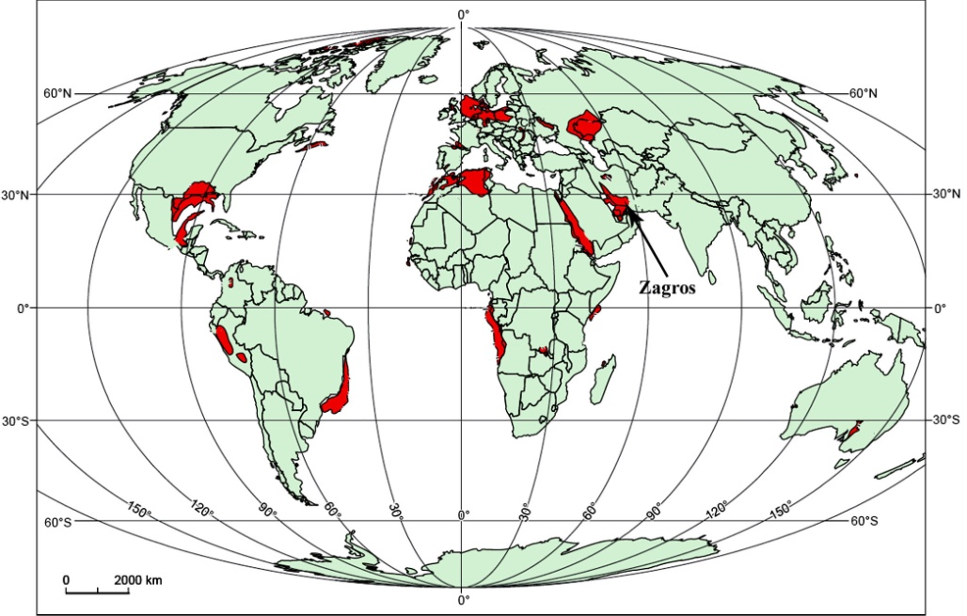
Fig. 1. Global distribution of salt basins (Jackson and Hudec, 2017).
Many diapirs were close to the surface (Jahani et al., 2007) and some had reached even the surface in Triassic times (Ala, 1974). Extensive activity in Lower Cretaceous related to inversion of lateral extension to lateral shortening during collision between two continents. The compressive events during Late Cretaceous-Tertiary rejuvenated the salt ascent for most of the diapirs and a majority of them breached to the surface due to folding and erosion (Callot et al., 2012).
Mesijune salt plug
The study area is part of the Zagros Fold and Thrust Belt and is located 295 km SE of Shiraz city. Figure 2a and b shows the location of study area in the Zagros Fold and Thrust Belt and the satellite image of the Mesijune salt diaper. Bondasht and Gach anticlines are the most important anticlines in the study area. the outcrops of the Hormoz salt series with the Infra-Cambrian age is the oldest rock unit and the upper Cretaceous rock units (Tarbour Formation) to Cenozoic rock units (Sachun, Asmari, Gachsaran, Mishan, Aghajari and Bakhtiari conglomerates) and recent alluvial deposits are the most important outcrops in the study area. Figure 3 shows the geological map of the study area.
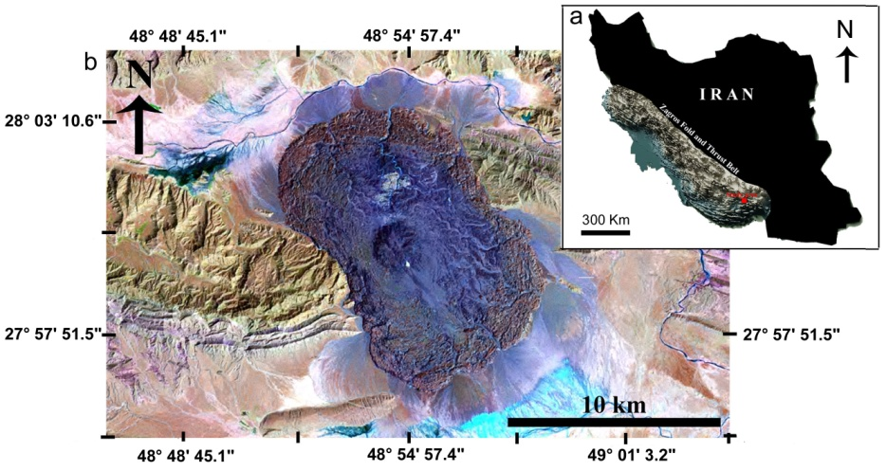
Fig. 2. a) Shaded relief map of Zagros Fold and Thrust. b) Satellite image of the Mesijune salt diaper.
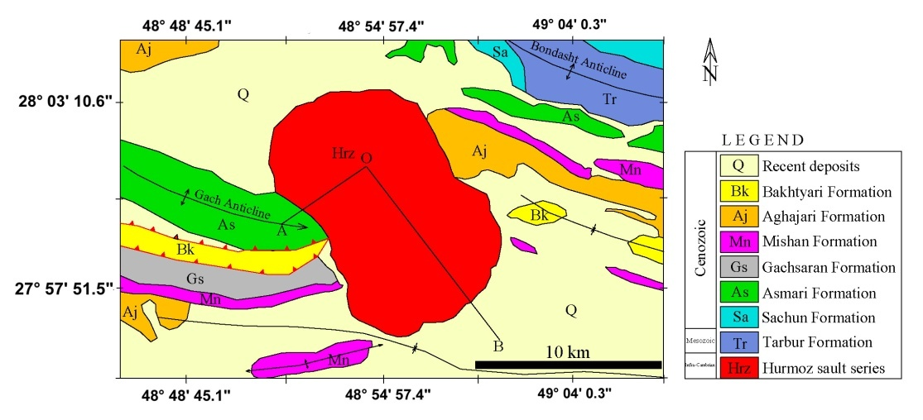
Fig. 3. The geological map of the study area.

The Mesijune salt plug has been exposed at the southern plunge of the Ghach anticline with a maximum length of 15 km and minimum width 8 km. The Mesijune salt plug structure is composed of two parts, i.e. of the plug itself and of the large areal glacier flow completely encircling the core (Bosák et al., 1998; Elliott et al., 2024). The Mesijunediapir, forms the largest salt glacier in Iran with uplift rate about 5 to 7 mm/year (Shami et al., 2024). It has the classic fried-egg geometry of a salt fountain, with a prominent summit dome (Fig. 4 a, b). The plug core is small and circular elevated structure with diameter of 2 km. The summit lies at 1,368 m a.s.l. and it is surrounded by the summit plateau about 1 km wide, with the basis at 1,300 m a.s.l. The plug foothills are at 1,100 to 1,180 m a.s.l. Triangular scarp (facet) of Tertiary sediments protrudes from steep south-eastern plug slope (Bosák et al., 1998). The salt glacier extended rather to structural valley in the NW and SE (syncline axes), than in the perpendicular direction where the flow was blocked by morphological elevations of anticline core built of Tertiary sediments (Bosák et al., 1998). The size of plug core and of glacier flow indicate intensive diapirism, whose beginning is difficult to date (?Pliocene), as no plug-derived material was discovered in Tertiary formations of the anticline (Bosák et al., 1998).
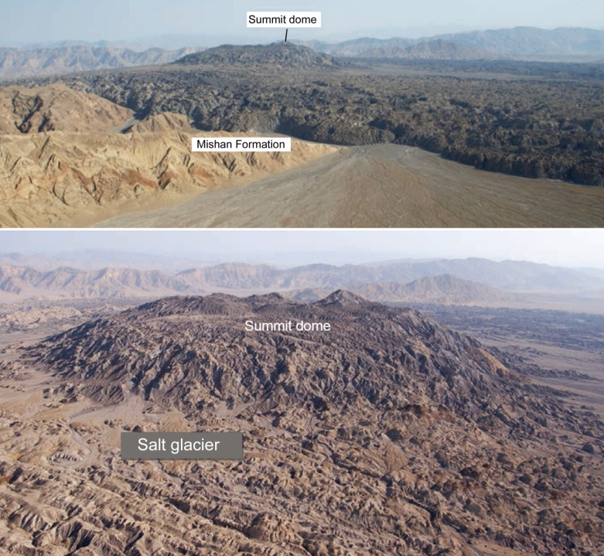
Fig. 4. a) The Mesijune salt glacier flows over the Holocene alluvium. b) Eroded salt from the summit dome is deposited atop other parts of the salt glacier. Aerial view looking northwest, photographs by Jean Letouzey (Alsop et al., 1996).
Material and methods
In the present study, Landsat 8 OLI and TIRS sensors data of 11 December 2024 (morning time) was used to remotely sense land surface temperature (LST). Thermal sensors are able to retrieve surface temperature by recording the thermal radiance emitted from the ground surface. There are different remote sensing methods such as Single-Window, Split-Window and Dual-Angle algorithms can be used for LST estimation. Due to that surface temperature is a key parameter in the physics of surface phenomena behaviors, its calculation accuracy may be affected by different factors which must be considered in the mentioned algorithms. In this research, because of that Landsat 8 satellite provides two thermal bands in the wavelength range of 10.5 and 12.5 μm, the Split-Window algorithm has been used to consider the total energy emitted in these two ranges for LST calculation. Figure 5 shows the flowchart of land surface temperature calculation using the Split-Window algorithm.
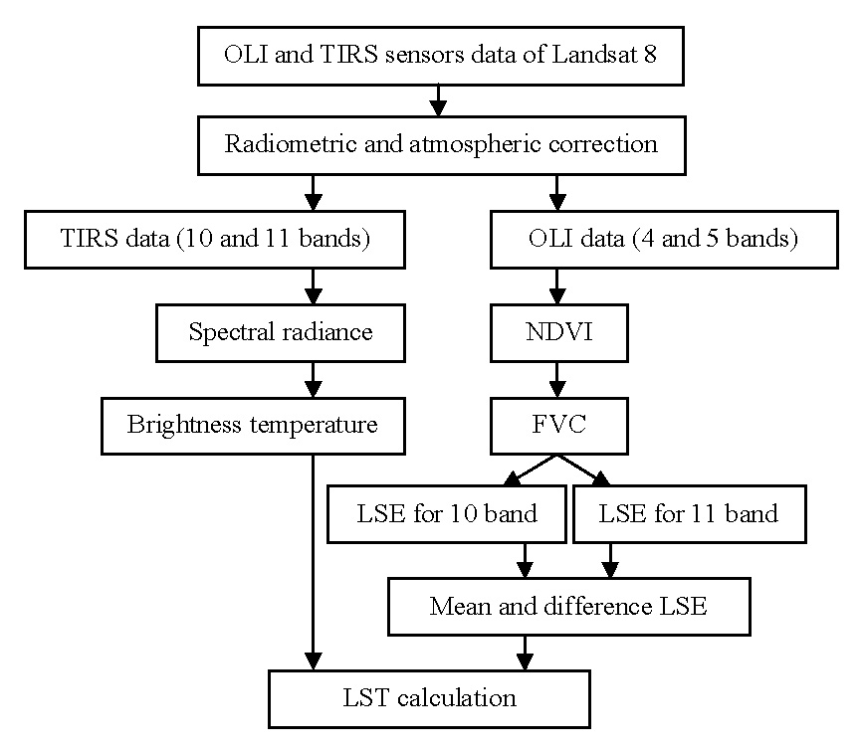
Fig. 5. The flowchart of LST calculation using the Split-Window algorithm.
Discussion and results
Normalized difference vegetation index (NDVI)
The normalized difference vegetation index (NDVI) can be considered as one of the effective and vital factors for LST calculation, due to that this index has an important role in energy transfer between earth surface and atmosphere, and affects different climatic elements, including surface temperature. This index is most sensitive to vegetation cover changes and is less sensitive to the atmospheric effects and soil conditions (except in areas with low vegetation cover). Red (4) and Near-Infrared (5) bands of Landsat 8 images are used to calculate the NDVI vegetation index using following equation (Reutter et al., 1994, Rajeshwari and Mani, 2014):
NDVI=(NIR-Red)/(NIR+Red) (1)
The output values of NDVI index are in the range of -1 and 1. Negative values, zero and up to 0.1 in this index indicate the absence of vegetation and larger values than 0.1 show areas with poor vegetation cover to dense vegetation in the range of 0.8-1. Figure 6 shows the NDVI map on the Mesijune salt dam that is in ranges of -1 to 0.2 with poor vegetation cover.
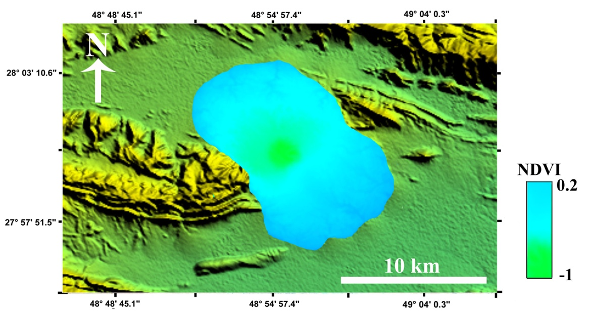
Fig. 6. NDVI index map in the Mesijune salt plug.
Fractional vegetation cover (FVC)
Fractional Vegetation Cover (FVC) index is one of the main parameters that have been used in many environmental and climate change studies. A common approach to calculate FVC by using equation 2 involves a nonlinear combination of two spectral elements of bare soil and green vegetation using satellite images (Shaouhua et al., 2009; Rajeshwari and Mani, 2014).
FVC=(NDVI-NDVI_{S})/(NDVI_{V}-NDVI_{S}) (2)
Where, NDVI_{S} is bare soil NDVI with 0.2 value and NDVI_{V} = 0.8 is used as NDVI value of dense vegetation cover.
Land Surface Emissivity (LSE)
Land Surface Emissivity (LSE) is a necessary factor for calculating LST index. This factor is separately calculated using both thermal bands of Landsat 8 for vegetation and soil. The calculation of LSE index is performed using the following formula (Shaouhua et al., 2009; Rajeshwari and Mani, 2014):
$LSE=(ε_{v}×FVC)+\left(ε_{s}×\left(1-FVC\right)\right)+dε$ (3)
Where, for Landsat 8, the following values were used: $ε_{v}$ = 0.987 for channel 10 and 0.989 for channel 11; $ε_{s}$ = 0.971 for channel 10 and 0.977 for channel 11. FVC is fractional vegetation cover (Zareie et al., 2020). $dε$that shows the geometric distribution effect of natural surfaces and their internal reflection is not considered for areas with little height difference.
Spectral radiance
Spectral radiance ($L_{λ}$) for thermal bands of Landsat 8 is calculated using the following equation (Shaouhua et al., 2009; Rajeshwari and Mani, 2014):
$L_{λ}=M_{L}×QCAL+A_{L}$(4)
Where, $A_{L}$ and $M_{L}$ extracted from metadata of Landsat 8 are 0.1 and 0.0003342, respectively. And, $QCAL$ is raster of the 10th or 11th channel of Landsat 8.
Brightness temperature (BT)
Top of atmosphere temperature measured by sensors from space is known as brightness temperature (BT), which is less affected by atmospheric absorption and diffusion than the land surface temperature (Reutter et al., 1994). The following equation is used to convert spectral radiance to brightness temperature (Juan et al., 2014, Zareie et al., 2020):
$BT=\frac{K_{2}}{L_{n}\left(\left(\frac{K_{1}}{L_{λ}}\right)+1\right)}$ (5)
Where, TB is the satellite brightness temperature (Kelvin), and L_{λ} is the spectral radiance (w/(m2 × ster × μm)). Calibration constants of $K_{1}$ and $K_{2}$have the following different values for channels 10 and 11: $K_{1}=774.89$, $K_{2}=1321.08$ for band 10, and $K_{1}=480.89$, $K_{2}=1201.14$for band 11.
Land surface temperature
Land surface temperature (LST) is calculated by Split Window Algorithm using the parameters of water vapor content in atmosphere, brightness temperature for both bands 10 and 11, land surface emissivity, and the fractional vegetation cover (Juan et al., 2014, Zareie et al., 2020). Brightness temperature was converted to the LST index (Fig. 7 a, b and c) using the following equation (Zareie et al., 2020):
$LST={BT}_{10}+\left(C_{1}×\left({BT}_{10}-{BT}_{11}\right)\right)+\left(C_{2}×{\left({BT}_{10}-{BT}_{11}\right)}^{2}\right)+C_{0}+\left(\left(C_{3}+C_{4}×W\right)×\left(1-ε\right)\right)+\left(\left(C_{5}+C_{6}×W\right)×∆ε\right)$(6)
Where, W is the water vapor content in atmosphere, ε = (ε10 + ε11)/2, and BT10 and BT11 are the brightness temperature of bands 10 and 11 (Kelvin) and Δε = ε10 − ε11. The equation’ coefficients are shown in the table 1.
Table 1. The values of constant coefficients $C_{0}$ - $C_{6}$ (Shaouhua et al., 2009; Rajeshwari and Mani, 2014, Zareie et al., 2020).
Value | constant coefficient
-0.268 | $$C_{0}$$
1.378 | $$C_{1}$$
0.183 | $$C_{2}$$
54.300 | $$C_{3}$$
-2.238 | $$C_{4}$$
-129.200 | $$C_{5}$$
16.400 | $$C_{6}$$
The main factor in the higher temperature of salt dome masses compared to adjacent rock units is related to the higher heat transfer coefficient of salt than to the other rocks. Figure 8 schematically shows higher heat flow on salt masses than neighboring rocks due to the higher heat transfer coefficient of salt and better transfer of geothermal energy over a salt mass.
Due to tectonic pressures, the ascending column of salt may become so thin and compact that it is completely disconnected from the source of the salt layer. Therefore, various types of underground salt formations may be formed. The application of tectonic forces and compressive-tensile shear stresses, lateral temperature changes and the subsidence of the upper layers on the salt, create vertical and horizontal complex flows in the salt masses. The upward movement of the salt dome by the diapirism mechanism mainly depends on the density difference between the salt and the overlying rocks, the temperature and the size of the salt mass (Jackson and Hudec, 2017). Increasing these three parameters makes the salt dome move faster and its height.
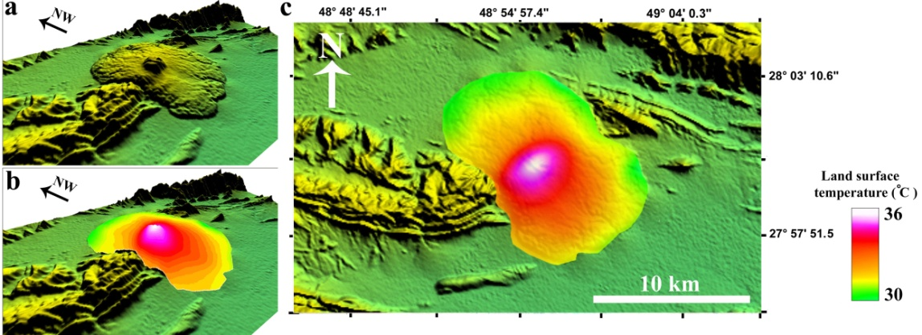
Fig. 7. a) Oblique digital elevation model of Mesijune salt plug. b and c) oblique and vertical LST map of Masijune salt plug.
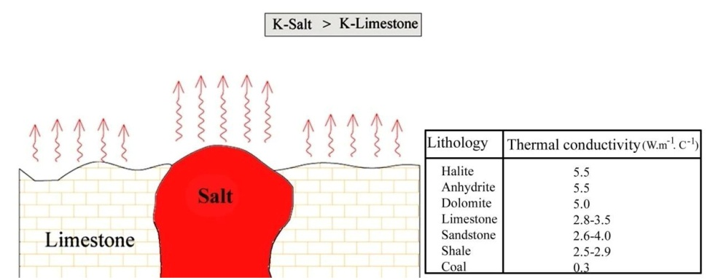
Fig. 8. Higher heat flow on salt masses than neighboring rocks due to higher heat transfer coefficient of salt.
The LST studies by Rangzan et al., 2016 on the Jahani, Konarsiyah and Khurab salt domes in the Zagros region had shown an increasing mode of land temperature in specific geographical directions in all three domes. Comparison of the topographic profile of these salt domes and the surface temperature shows a direct relationship between the height and the surface temperature in these salt domes. The thermal pattern obtained for the Mesijune salt plug shows that the amount of temperature difference from the top of the salt plug to the edges of the salt glacier is about 6°C. The highest temperature at the top of the dome is about 36°C and the lowest temperature in the northern and northeastern salt glacier margins is about 30°C (Fig. 7). Structurally, the higher temperature of the salt dome at the top of the dome can probably be related to the rooting of this dome and its connection with the basement salt layer. Figure 9 shows a 3D structural and thermal model of the Mesijune salt dome. Accordingly, the amount of surface temperature from the center or summit of the dome to the lateral salt glacier shows a significant reduction. In this figure, the red color spectrum in the salt dome is a criterion for the salt temperature.
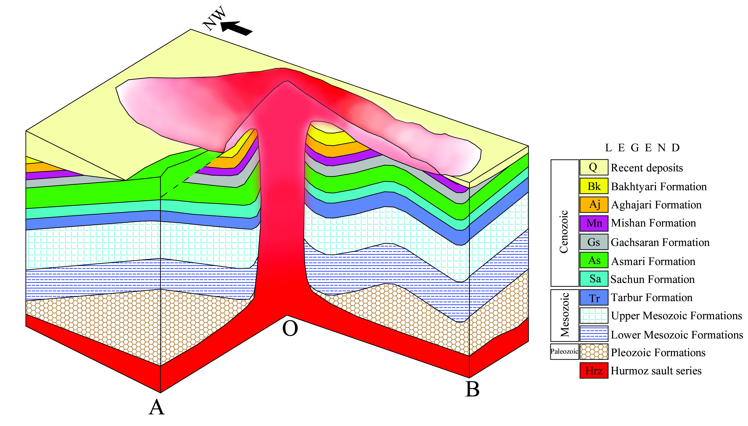
Fig. 9. 3D structural model of the Mesijune salt plug. Schematically, the changes in the intensity of the red color in the salt dome indicate a thermal anomaly in different parts of it.
Conclusion
One of the most important aspects of remote sensing in climatological studies is the estimation of land surface temperature. The Split-Window algorithm is considered as an effective method in extracting the land surface temperature. According to the resulted LST map of the Mesijune salt plug the highest temperature is 36°C at the summit and the lowest temperature is 30°C at the marginal salt glacier of the salt dome. This temperature difference from the summit to the margins of the salt plug is related to the direct connection of the summit of the salt plug with the deep source salt layer on the Zagros basement. The thermal pattern of the Mesijune salt plug reveals the direct relationship between the salt temperature and topography pattern. So that in higher parts of the plug it has higher temperature than lower parts of the salt glacier.

References
Ala, M. A., 1974. Salt diapirism in southern Iran. Am. Assoc. Geological Bulletin. 58, 758–70.
Alavi, M., 1994. Tectonics of the Zagros orogenic belt of Iran: new data and interpretations. Tectonophysics. 229, 211–238.
Alavi, M., 2004. Regional stratigraphy of the Zagros Fold-Thrust Belt of Iran and its proforeland evolution. American Journal of Science. 304, 1–20.
Alipour, M., Alizadeh, B., & Mirzaie, S., 2022. Petroleum system analysis of the Paleozoic series in the Fars Platform of Iran. Journal of Petroleum Sciences and Engineering. 208, 109557.
Allen, M. B., Jackson, J., & Walker, R., 2004. Late Cenozoic reorganization of the Arabia-Eurasia collision and comparison of the short-term and long-term deformation rates. Tectonics. 23, 639–654.
Al-Siyabi, H. A., 2005. Exploration history of the Araintrasalt carbonate stringers in the South Oman Salt Basin. Geologia Arabia. 10, 39–72.
Bahroudi, A., 2003. The effect of mechanical characteristics of basal decollement and basement structures on deformation of the Zagros Basin. Ph.D. Thesis, Uppsala University, pp. 223.
Berberian, M., & King, G. C. P., 1981. Towards a paleogeography and tectonic evolution of Iran. Canadian Journal of Earth Sciences. 18, 210–265.
Beydoun, Z. R., Hughes, M. W., & Stoneley, R., 1992. Petroleum in the Zagros basin: a late Tertiary foreland basin overprinted onto the outer edge of the vast hydrocarbon-rich Paleozoic-Mesozoic passive margin shelf. Am Assoc. Geological Bulletin. 55, 307–336.
Bosák, P., Jaros, J., Spudil, J., Sulovsky, P., & Vaclavek, V., 1998. Salt diapirs in the Eastern Zagros, Iran: results of regional geological reconnaissance. Inst. Geological Academic Sciences. Czech Repub. 7, 3–174.
Burton, Z. F. M., &Dafov, L. N., 2023. Salt diapir-driven recycling of gas hydrate. Geochem. Geophys. Geosyst. 24, e2022GC010704.
Callot, J. P., Trocme, V., Letouzey, J., Albouy, E., Jahani, S., & Sherkati, Sh., 2012. Preexisting salt structures and the folding of the Zagros Mountains. Geological Society of London. 363, 545–561.
Edgell, H. S., 1996. Salt tectonism in the Persian Gulf basin. In G. I. Alsop, D. Blundell, & I. Davison (Eds.), Salt Tectonics (Special Publications, 100, pp. 129–151). Geological Society, London.
Elliott, J., Watson, A., Lazecky, M., Maghsoudi, Y., McGrath, J., & Payne, J., 2024. An InSAR-GNSS velocity field for Iran. Copernicus Meetings.
Faghih, A., Dehghan, M., & Sobhani, S. S., 2023. Study of deformation pattern and kinematic characteristics in the Gelmandeh metamorphic complex, Saghand region, Central Iran. Advanced Applied Geology. 12(4), 617–634.
Fossen, H., 2016. Structural Geology. Cambridge University Press, 567 pp.
Geiger, S., Driesner, T., Heinrich, C. A., &Mattha, S. K., 2006. Multiphase thermohaline convection in the Earth’s crust: II. Benchmarking and application of a finite element-finite volume solution technique with a NaCl–H2O equation of state. Transp Porous Media. 63, 435–461.
Haynes, S. J., & McQuillan, H., 1974. Evolution of the Zagros Suture zone, southern Iran. Geological Society of America Bulletin. 85, 739–744.
Hughes, J. D., & Sanford, W. E., 2004. SUTRA - MS: a version of SUTRA modified to simulate heat and multiple-solute transport. US GeolSurv Open-File Rep. 1207, 152.
Hudec, M. R., & Jackson, M. P. A., 2007. Terra Infirma: understanding salt tectonics. Earth Sci. Rev, 82, 1–28.
Husseini, M. I., & Husseini, S. I., 1990. Origin of the Infra-Cambrian salt basin of the Middle East.In J. Brooks (Ed.), Classic Petroleum Provinces (Vol. 50, pp. 279–292). Geological Society, London, Special Publication.
Jackson, M. P. A., & Hudec, M. R., 2017. Salt tectonics: principles and practice. Cambridge University Press, 518 pp.
Jackson, M. P. A., & Talbot, C. J., 1986. External shapes, strain rates and dynamics of salt structures. Geol. Soc. Am. Bull. 97, 305–328.
Jahani, S., Callot, J. P., Letouzey, J., & Frizon de Lamotte, D., 2009. The eastern termination of the Zagros fold and thrust belt (Iran): relationship between salt diapirs, folding and faulting. Tectonics. 28. http://dx.doi.org/10.1029/2008TC002418.
Jahani, S., Callot, J. P., Frizon de Lamotte, D., Letouzey, J., &Leturmy, P., 2007. The salt diapirs of the eastern Fars province (Zagros, Iran): a brief outline of their past and present. In O. Lacombe, J. Lavé, F. Roure, & J. Vergés (Eds.), Thrust Belt and Foreland Basin (pp. 289–308). Springer Berlin Heidelberg.
Juan, C., Jimenez-Munoz, J., Sobrino, A., Skokovic, D., Mattar, C., & Cristobal, J., 2014. Land surface temperature retrieval methods from Landsat-8 thermal infrared sensor data. IEEE Geoscience and Remote Sensing Letters, 11(10).
Kent, P. E., 1970. The salt diapirs of the Persian Gulf region. Trans. Leic. Lit. Philos. Soc., 64, 56–88.
Kent, P. E., 1979. The emergent Hormuz salt diapirs of southern Iran. J. Pet. Geol. 2, 117–144.
Keshavarz, S., & Faghih, F., 2020. Heterogeneous sub–simple deformation in the Gol–e–Gohar shear zone (Zagros, SW Iran): insights from microstructural and crystal fabric analyses. International Journal of Earth Sciences. 109, 421–438. DOI: 10.1007/s00531-019-01812-9.
Keshavarz, S., Faghih, A., Asadi, S., Soleimani, M., & Zarei, S., 2024. PT conditions of deformation of the Gol-e-Gohar shear zone, SW Iran: Insights from analysis of quartz c-axis fabrics, recrystallization mechanisms and syndeformational fluid inclusions. Journal of Asian Earth Sciences. 262, 106010.
Lacombe, O., Mouthereau, F., Kargar, S., & Meyer, B., 2006. Late Cenozoic and modern stress fields in the western Fars (Iran): implications for the tectonic and kinematic evolution of central Zagros. Tectonics, 25.
Mohajjel, M., Fergusson, C. L., & Sahandi, M. R., 2003. Cretaceous–Tertiary convergence and continental collision, Sanandaj–Sirjan Zone, western Iran. Journal of Asian Earth Sciences. 21, 397–412.
Motamedi, H., Sepehr, M., Sherkati, Sh., & Pourkermani, M., 2011. Multi-phase Hormuz salt diapirism in the Southern Zagros, SW Iran. J. Pet. Geol. 34, 29–44.
Nance, R. D., Gutierrez-Alonso, G., Keppie, J. D., Linnemann, U., Murphy, J. B., Quesada, C., Strachan, R. A., & Woodcock, N. H., 2010. Evolution of the Rheic Ocean. Gondwana Research. 17, 194–222.
Player, R. A., 1969. The Hormuz Salt Diapirs of Southern Iran. Ph.D. Thesis, Reading University, pp. 300.
Rajeshwari, A.1, Mani, N. D., 2014. Estimation of Land Surface Temperature, Of Dingdigul District Using Landsat 8 data, IJRET: International Journal of Research in Engineering and Technology. 2319-1163, doi: 10.15623/ijret.2014.0305025.
Ranganathan, V., 1992. Basin dewatering near salt domes and formation of brine plumes. J. Geophys. Res. 97, 4667–4683.
Rangzan, K., Kabolizadeh, M., Karimi, D., & Zareie, S., 2019. Supervised cross-fusion method: a new triplet approach to fuse thermal, radar, and optical satellite data for land use classification. Environ. Monit. Assess. 191, 48.
Rangzan, K., Kavosi, F., Samani, B., & Saberi, A., 2016. Evaluating heat flow anomalies in Jahani, Konar-e Siah and Khorab salt domes structure using OLI and TIRS sensors images of Landsat 8. Journal of Advance Applied Geology. 25, 35–48.
Reutter, H., Olesen, F-S., Fischer, H., 1994. Distribution of the brightness temperature of land surfaces determined from AVHRR data, Remote Sensing. 15 (1), 95-104, doi:10.1080/01431169408954053.
Sepehr, M., & Cosgrove, J. W., 2005 .Role of the Kazerun fault zone in the formation and deformation of the Zagros Fold-Thrust Belt, Iran. Tectonics, 24.
Shami, S., Shahriari, M. A., Nilofouroushan, F., Forghani, N., Salimi, M., & Reshadi, M. A. M., 2024. Surface displacement measurement and modeling of the Shah-Gheyb salt dome in southern Iran using InSAR and machine learning techniques. International Journal of Applied Earth Observation and Geoinformation. 132, 104016.
Shaouhua, Z., Qiming. Q., Yonghui, Y., Yujiu, X., Guoyu, Q., 2009. Comparison og two SplitWindow Mehtods for Retrieving Land Surface Temperature from MODIS Data , Journal of Earth Syst. Science, Vol.118, (4), 345-353, doi: 10.1007/s12040-009-0027-4.
Stöcklin, J., 1968. Structural history and tectonics of Iran: A review. American Association of Petroleum Geologists Bulletin. 52, 1229–1258.
Stöcklin, J., 1974. Possible ancient continental margins in Iran. In C. A. Burk & C. L. Drake (Eds.), The Geology of Continental Margins (pp. 873–887). Springer, New York.
Talbot, C. J., 1998. Extrusions of Hormuz salt in Iran. In D. J. Blunderll& A. C. Scott (Eds.), Lyell: The Past is the Key to the Present (Vol. 143, pp. 315–334). Geological Society, London, Special Publication.
Talbot, C. J., & Alavi, M., 1996. The past of a future syntaxis across the Zagros. In G. I. Alsop, D. J. Blunderll, & I. Davison (Eds.), Salt Tectonics (Vol. 100, pp. 89–109). Geological Society, London, Special Publication.
Talbot, C. J., Stanley, W., Soub, R., & Al-Sadoun, N., 1996. Epitaxial salt reefs and mushrooms in the southern Dead Sea. Sedimentology. 43, 1025–1047.
Talebian, M., & Jackson, J., 2002. Offset on the Main Recent Fault of NW Iran and implications for late Cenozoic tectonics of the Arabia–Eurasia collision zone. Geophysical Journal International. 150, 422–439.
Thorne, D., Langevin, C. D., & Sukopc, M. C., 2006. Addition of simultaneous heat and solute transport and variable fluid viscosity to SEAWAT. J. Comput. Geosci. 32, 1758–1768.
Vernant, P., Nilforoushan, F., Hatzfeld, D., Abbasi, M. R., Vigny, C., Masson, F., Nankali, H., Martinod, J., Ashtiani, A., Bayer, R., Tavakoli, F., & Chery, J., 2004. Present-day crustal deformation and plate kinematics in the Middle East constrained by GPS measurement in Iran and northern Oman. International Journal of Geophysics. 157, 381–398.
Younes, A., 2003. On modeling the multidimensional coupled fluid flow and heat or mass transport in porous media. Int. J. Heat Mass Tran. 46, 367–379.
Zareie, S., & Kabolizadeh, M., 2020. The natural resources potential assessing aimed at territorial planning using time-varying space data of vegetation index and LST. Environ. Monit. Assess. 192, 503.
Zareie, S., Khosravi, H., Nasiri, A., & Dastorani, M., 2016. Using Landsat Thematic Mapper (TM) sensor to detect change in land surface temperature in relation to land use change in Yazd, Iran. Solid Earth. 7, 1551–1564.

